|  |  |  |  |  |  |
| --- | --- | --- | --- | --- | --- |
| Date | 12-Dec-22 | | | Tester Name | Mayuri Patel |
| Environment | Penfax - Test | | | Login used |  |
| Operating System | Select OS | Version: | Update: | | |
| Software Used | Select Software | Version: | Update: | | |
| Select Software | Version: | Update: | | |
| Release version | 22.4.1 | | | | |
| Title |  | | | | |
| Test Type | Regression | | | | |
| Test Scenario | MLA Conflict of Interest Extract | | | | |
|  |  | | | | |
| Expected Results |  | | | | |
| Pass/Fail | Pass | | | JIRA# | N/A |

Describe your steps with screenshots:

Go to Batch processes

Enter Batch Process Type to MLA Extract for Conflict of Interest Report and Search

Select the recent report

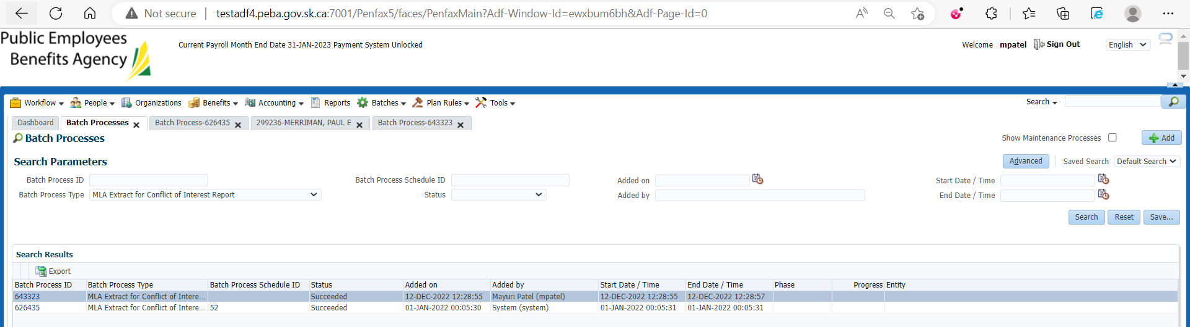

Download the report from under the files tab

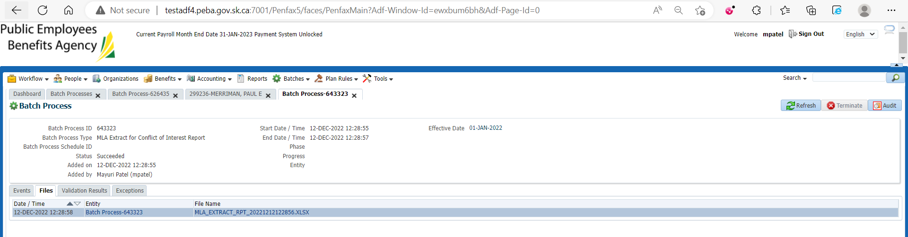

Open that report

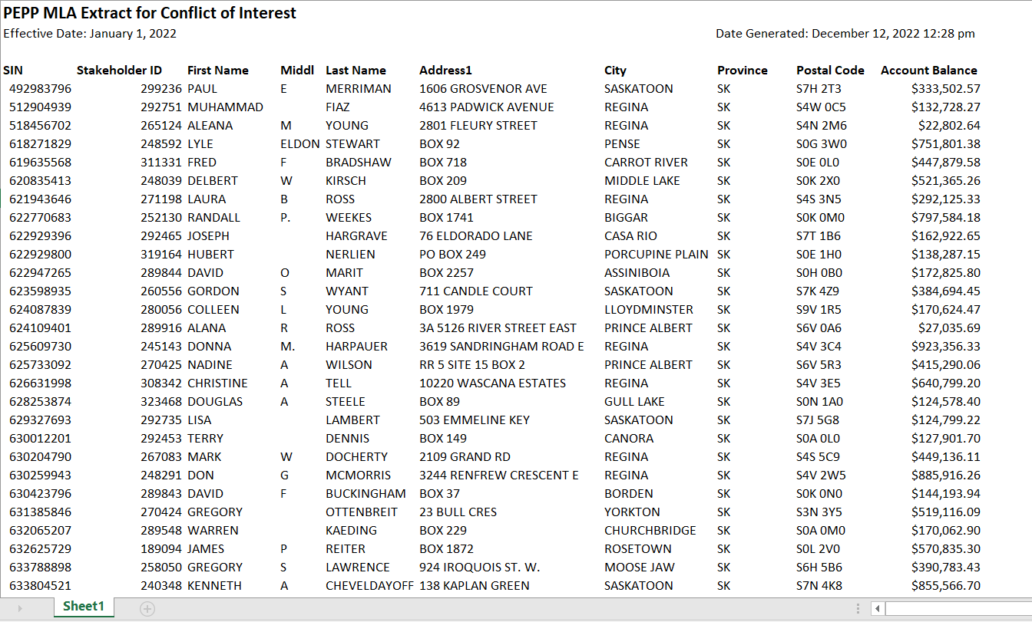

Verify the values

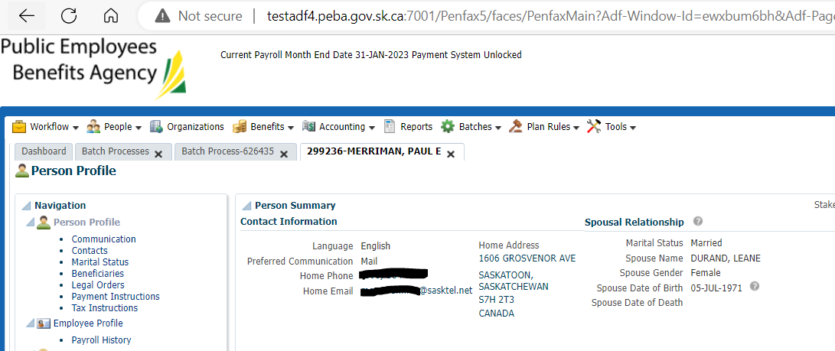

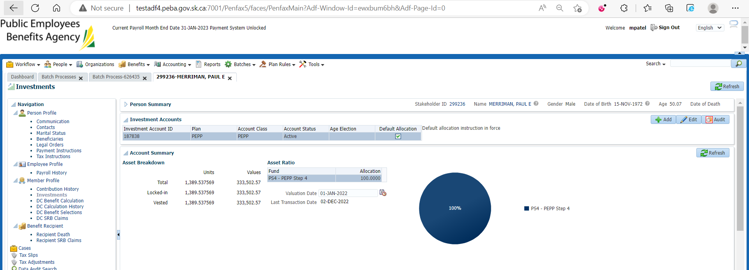

Likewise do for all members

MLA Conflict of Interest Extract Report is saved at: H:\Quality Assurance\Prod Apps\Testing Management\Regression Testing\Nov 2022 - PENFAX 22.4.1 Release\PEPP\Test Results\E28 Extracts